**How-to Create a New EC2 Instance Key Pair**

**1.** Use the below URL for login to AWS account.

http://aws.amazon.com/

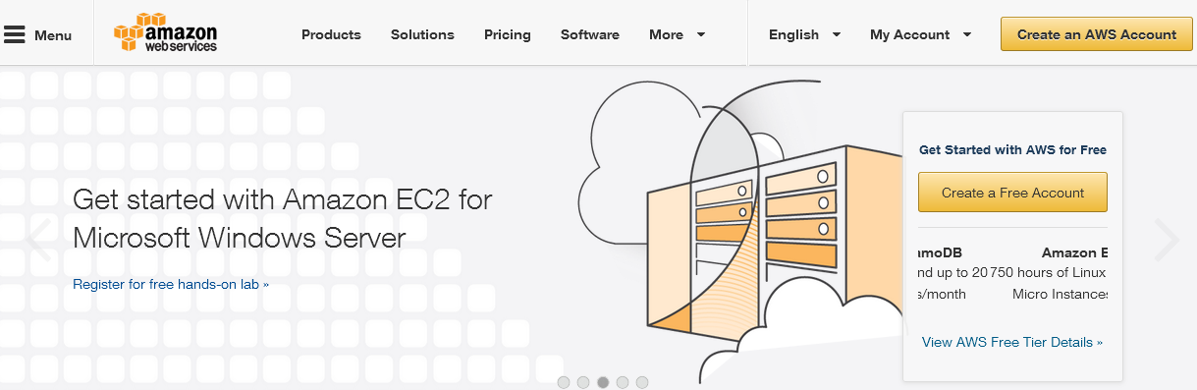

**2.** Login to your AWS account.

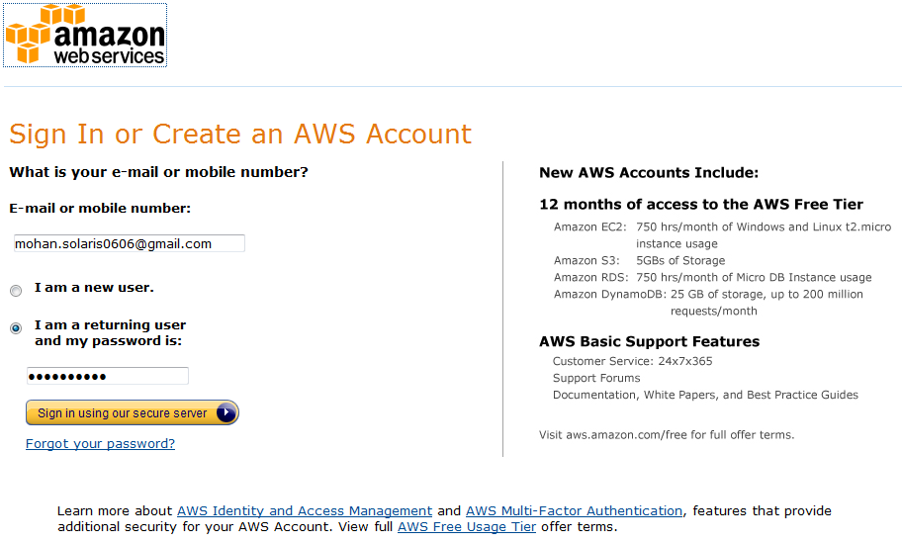

**3.** Go to AWS Management console:-

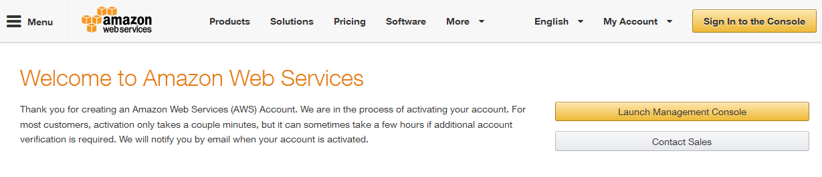

**4.** Go to AWS console.

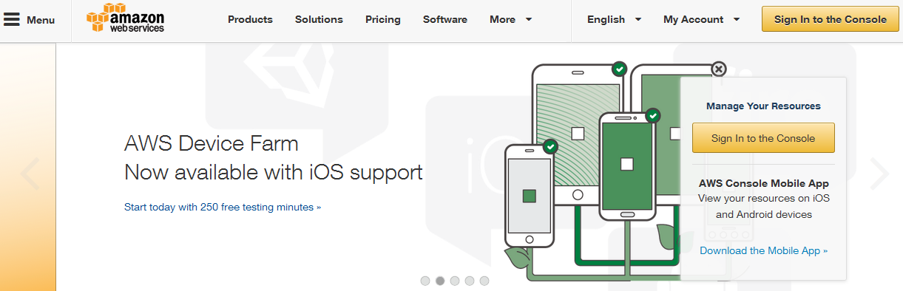

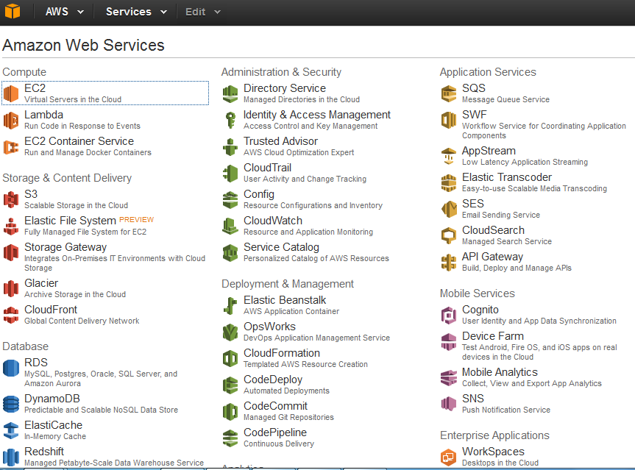

**5.** Select EC2 from above mentioned services.

**6.** Select any of the regions from the left hand side drop down. E.g. we have selected ‘US-West

(Oregon)’.

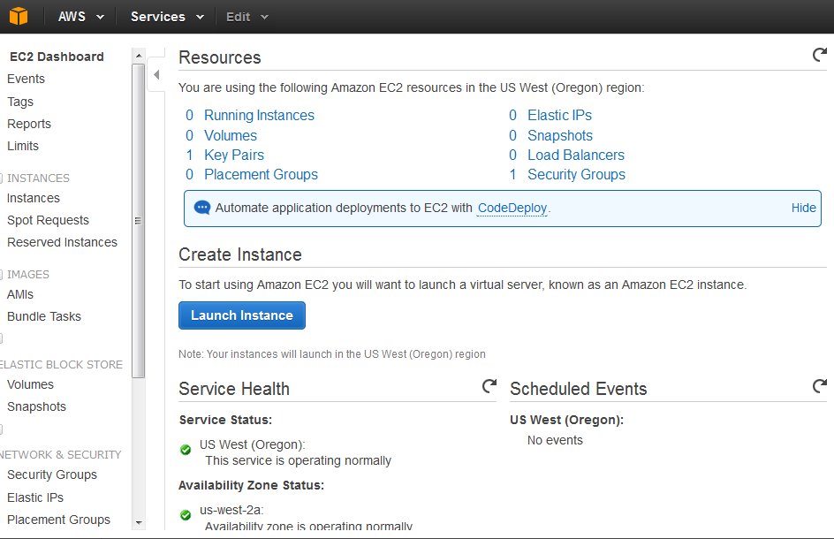

**7.** It will list summary of all EC2 activities like number of running instances, EBS volumes, ElasticIPs etc.



**8.** Select “Key Pairs” from left menu. (EC2 Dashboard). Here will appear all your AWS existing key pairs.

If none click to create the first.

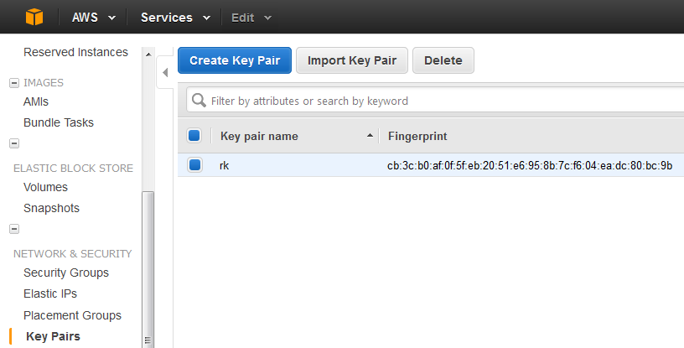

**9.** Click on ‘Create Key Pair’ button. Enter the logical name of key pair you want to create.

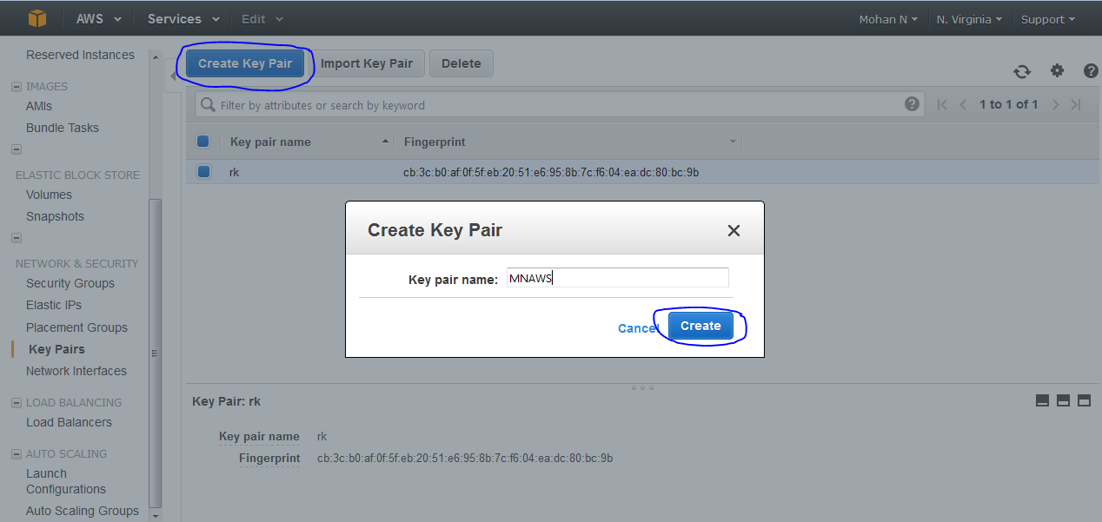

**10.** AWS will create a new key-pair with name ‘MNAWS’ and it will ask you to download the newly

generated private key file (here MNAWS.pem).

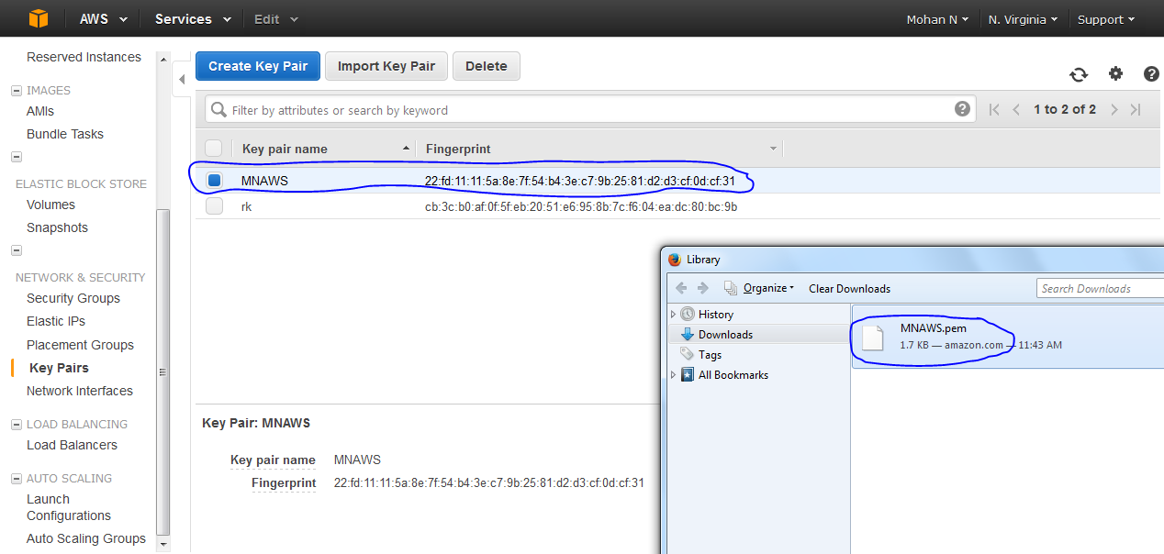

**NOTE:**

*1. If you lose the key you will never be able to get it back.*

*2. If you have launched an instance with a key pair and by mistake you lost the key, you will not be able to*

*login to the same instance using same key.*

**11.** As shown above you have created the key-pair file which can be used when you want to make secure

instance launch.

`

**12.** To windows instance or for windows machine, we need to convert it from .pem format to .ppk format using puttygen.

